# GLA University

**Institute of Engineering & Technology**

**MINI PROJECT**

**(2020-2021)**

**COVIDOPEDIA**

**MID-TERM REPORT**

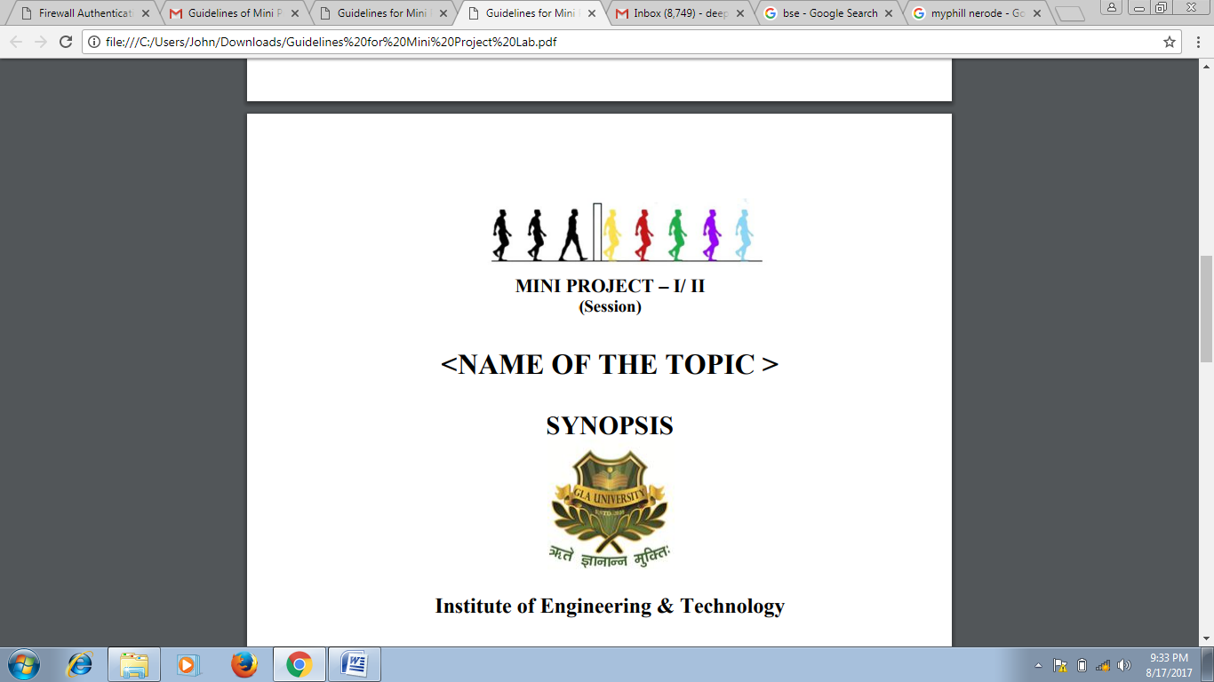

**Team Members**

Aman Jadon (181500071)

Priya Rajput (181500507)

Ritika Agrawal (181500581)

Sakshi Goyal (181500609)

Samarth Kulshrestha (181500610)

**Under the Supervision**

**Of**

Prof. Mandeep Singh

Technical Trainer

Department of Computer Engineering and Applications

**Contents**

**Abstract**

1. **Introduction**

**2. Problem Definition**

**3. Objectives**

1. **Implementation Details**
2. **Progress till Date and the remaining work**
3. **Some Screenshots**

**References**

**Abstract**

In this project, we are creating a fully responsive website on the global pandemic, COVID-19. We have named our website COVIDOPEDIA. Our website will be a better and all in one place to get people updated about it. As the name suggests, our website will be giving out all information about this disease, whether it comes to symptoms, precautions or anything else. Our website contains navigation bar which will be navigating users to different parts of the website. User can get the daily updates of the disease and also can get information according to his/her country. We will also be predicting the health risk of a person according to his symptoms and other sufferings. One thing that has also been emerged this pandemic are myths related to its treatments or symptoms, so we will also have that segment where we will be clearing out this myths and providing you the actual information. The user can give their information and contact to us with the help of our contact page where you need to fill your email id and other important details. Our FAQ section will let all the users know all the necessary details about the website.

Since this pandemic has taken over the world for so long, so our websites will be quite suitable in present scenario.

**Introduction**

* **General Introduction to the topic**

Covidopedia is a fully responsive and a user-friendly website. On it’s homepage, provided a navigation bar which will navigate you to different parts of the website. On the homepage you will see a world map, which will be showing the active number of corona cases all over the world and if the user want to get more info about the cases then he/she can click on the read more option which will be showing tabular data consisting the active cases, recovered cases and deaths. Also, you will get a search option where you can search any country’s data.

Then comes the brief introduction about the disease, from where it is generated and other basic information. After that comes the other part, symptoms of the disease and its prevention. Another section which is also present is Myth section, where we will be giving information about the myths that spread across the world during this pandemic. They will be given in brief, it’s user choice if they want to know more, they can always click on read more. We also get that section where we will be predicting the health risk of a person on the basis of the symptoms he provide. The user can also contact us through the contact page. We have also provided FAQ section.

And at last for testing our website, we will be deploying our website on a online web hosting platform.

* **Key Features of the website – COVIDOPEDIA**

1. Our website is **‘fully responsive’** which makes it suitable for various range of devices including desktop, tablets, mobile phones or any other devices.

2. A **‘Navigation Bar’** which will take us to the different part of the website.

3. A **‘World Map’** which will denote the active number of cases of COVID all over the world.

4. A **‘Search option’** which allows us to search the cases of a particular country among the different countries of the world.

5. A **‘Myth Section Carousel’** which contains all the false information which has been spread.

6. A **‘Preventions of COVID-19’** section.

7. A **‘Symptoms of COVID-19’** section.

8. A **‘FAQ Section’** section.

**Technologies Used**

**1. HTML :** Hypertext Markup Language (HTML) is the standard markup language for documents designed to be displayed in a web browser. Web browsers receive HTML documents from a web server or from local storage and render the documents into multimedia web pages. HTML describes the structure of a web page semantically and originally included cues for the appearance of the document.

HTML elements are the building blocks of HTML pages. With HTML constructs, images and other objects such as interactive forms may be embedded into the rendered page. HTML provides a means to create structured documents by denoting structural semantics for text such as headings, paragraphs, lists, links, quotes and other items.

**2. CSS :** CSS is designed to enable the separation of presentation and content, including layout, colors, and fonts.[3] This separation can improve content accessibility, provide more flexibility and control in the specification of presentation characteristics, enable multiple web pages to share formatting by specifying the relevant CSS in a separate .css file which reduces complexity and repetition in the structural content as well as enabling the .css file to be cached to improve the page load speed between the pages that share the file and its formatting.

**3. Bootstrap :** Bootstrap is a web framework that focuses on simplifying the development of informative web pages (as opposed to web apps). The primary purpose of adding it to a web project is to apply Bootstrap's choices of color, size, font and layout to that project. As such, the primary factor is whether the developers in charge find those choices to their liking. Once added to a project, Bootstrap provides basic style definitions for all HTML elements. The result is a uniform appearance for prose, tables and form elements across web browsers. In addition, developers can take advantage of CSS classes defined in Bootstrap to further customize the appearance of their contents. For example, Bootstrap has provisioned for light- and dark-colored tables, page headings, more prominent pull quotes, and text with a highlight.

Bootstrap also comes with several JavaScript components in the form of jQuery plugins. They provide additional user interface elements such as dialog boxes, tooltips, and carousels.

**4. MySQL :** MySQL is an open-source relational database management system (RDBMS). A relational database organizes data into one or more data tables in which data types may be related to each other; these relations help structure the data. SQL is a language programmers use to create, modify and extract data from the relational database, as well as control user access to the database. In addition to relational databases and SQL, an RDBMS like MySQL works with an operating system to implement a relational database in a computer's storage system, manages users, allows for network access and facilitates testing database integrity and creation of backups.

**5. PHP :** PHP is a general-purpose scripting language especially suited to web development. PHP code is usually processed on a web server by a PHP interpreter implemented as a module, a daemon or as a Common Gateway Interface (CGI) executable. On a web server, the result of the interpreted and executed PHP code – which may be any type of data, such as generated HTML or binary image data – would form the whole or part of a HTTP response. Additionally, PHP can be used for many programming tasks outside of the web context, such as standalone graphical applications and robotic drone control.

**6. jQuery :** jQuery is a JavaScript library designed to simplify HTML DOM tree traversal and manipulation, as well as event handling, CSS animation, and Ajax. It is free, open-source software using the permissive MIT License.

jQuery's syntax is designed to make it easier to navigate a document, select DOM elements, create animations, handle events, and develop Ajax applications. jQuery also provides capabilities for developers to create plug-ins on top of the JavaScript library. This enables developers to create abstractions for low-level interaction and animation, advanced effects and high-level, themeable widgets. The modular approach to the jQuery library allows the creation of powerful dynamic web pages and Web applications.

The principles of developing with jQuery are:

Separation of JavaScript and HTML: The jQuery library provides simple syntax for adding event handlers to the DOM using JavaScript, rather than adding HTML event attributes to call JavaScript functions. Thus, it encourages developers to completely separate JavaScript code from HTML markup.

Brevity and clarity: jQuery promotes brevity and clarity with features like "chainable" functions and shorthand function names.

Elimination of cross-browser incompatibilities: The JavaScript engines of different browsers differ slightly so JavaScript code that works for one browser may not work for another. Like other JavaScript toolkits, jQuery handles all these cross-browser inconsistencies and provides a consistent interface that works across different browsers.

Extensibility: New events, elements, and methods can be easily added and then reused as a plugin.

**Hardware and Software Requirements**

**Software Specification:**

* Technology Implemented : Full Stack
* Language Used : HTML, CSS, Bootstrap, PHP, JavaScript,

jQuery

* Database : Xampp
* IDE Used : VSCode, Xampp
* Web Browser : Chrome

**Hardware Requirements:**

* Processor : intel i5
* Operating System : Windows 10
* RAM : 8 GB
* Hardware Devices : Computer System
* Hard disk : 256 GB

**Problem Statement**

We have proposed a website which will offer every effect that the global pandemic have on everybody’s lives. The outbreak of coronavirus disease 2019 (COVID-19) has created a global health crisis that has had a deep impact on the way we perceive our world and our everyday lives. Mass media have long been recognized as powerful forces shaping how we experience the world and ourselves. In this time of evolving technology, it is really important to get yourself updated about the changes happening in the world. Since in the current situation, the world is suffering from COVID. So in order to get people informed about each and every change this pandemic is bringing on different parts of world, different category of the population, our website would be a helping hand.

**Objective**

In present scenario, there are websites which only tell us about the active number of cases and the number of recovered cases of a place. But we target to give overall effect of COVID on a place.

With this project we will be aiming to give user all the effects of COVID at one stop. Since this pandemic has shaken the whole world to its roots, it would have very drastic effects all over the world for a long period of time. So in order to notify yourself from all the future activities that can affect us our family or our mode of earning, its really important to have a stop where you can get daily updates.

**Implementation**

The website has been made by the following steps:

**Part 1:** To create the different sections of the website, we have HTML and CSS and displayed them. It includes sections like About COVID-19, Symptoms and Preventions of it.

**Part 2:** After creating all these sections, we have made the navigation bar to access the different parts of the website: home, updates, contact and the FAQ section.

**Part 3:** After completion of the navigation bar, implementation of the map part will be done with the help of JavaScript. In this when we click on know more, a table containing data of all the countries will be displayed which will also give a search facility. This will be implemented with the help of jQuery.

**Part 4:** After the completion of above parts, we have implemented the myth carousel part with the help of jQuery.

**Part 5:** Now for the last part, we have to deploy our website on an online web hosting platform.

**Progress**

Part 1: Home Page containing Navigation Bar (Done)

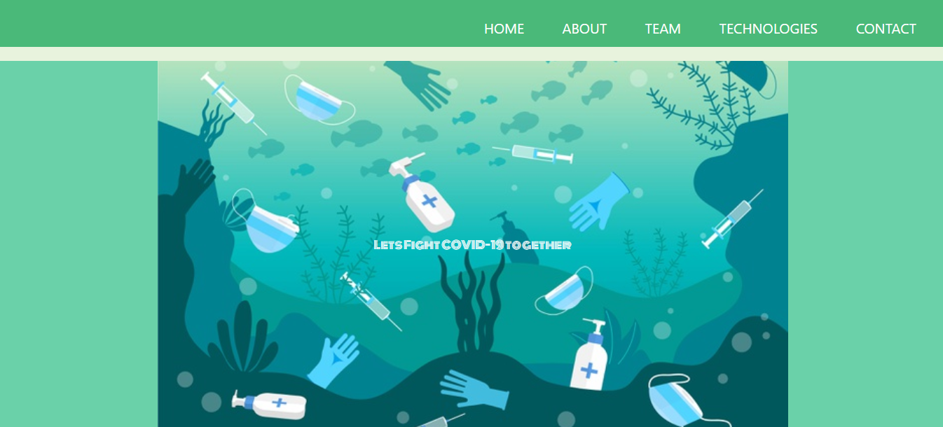

Part 2: Prevention against Coronavirus (Done)

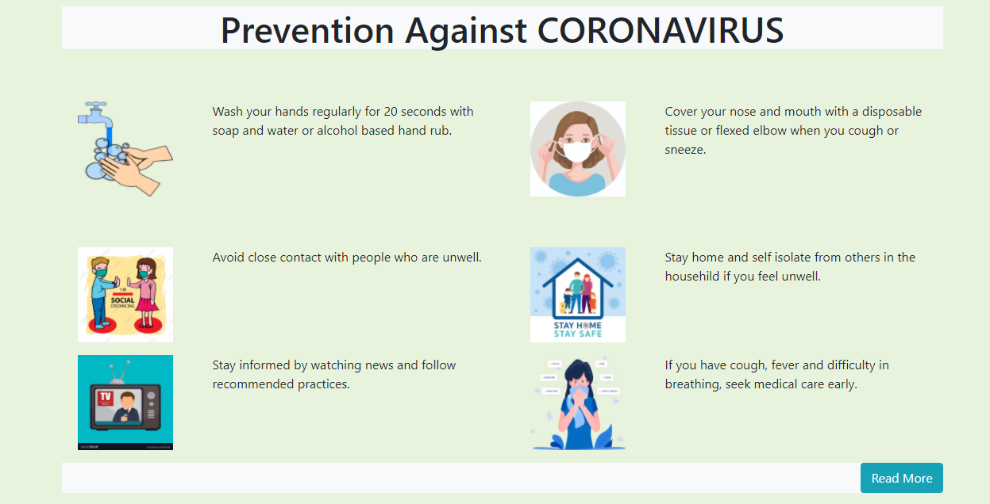

Part 3: Symptoms of Coronavirus (Done)

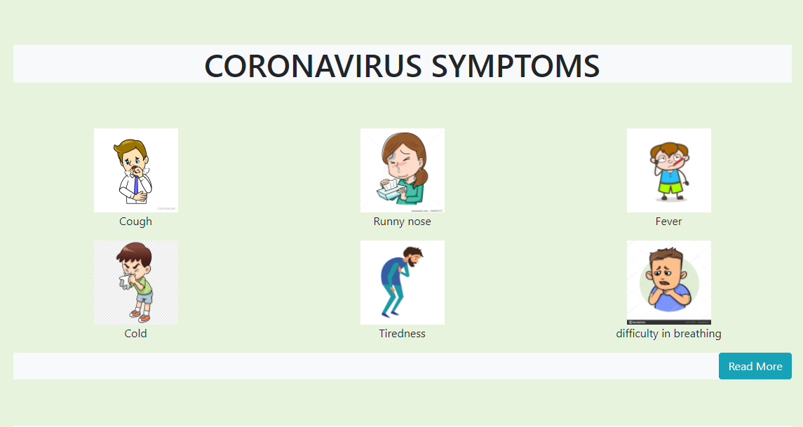

Part 4: Myths Carousel Section

